

SENECA COLLEGE NEWHAMN CAMPUS

COURSE WEB222 FALL 2022

TEST8

1. Create an HTML document that collects the following information from the user:

**16 Marks.**

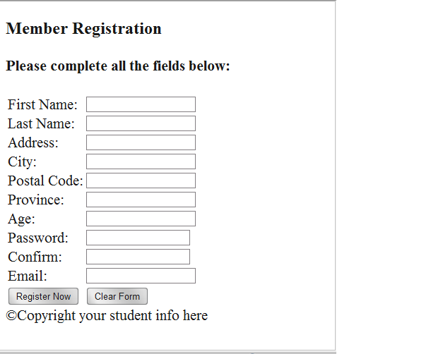

1. Create an event on the Register or submit Button to display the message. “Thanks for Registering”. **2 Marks**
2. Organize your form using css. **5 Marks**

Upload your zip folder to Test8 drop box.